Email Subject: guarantees 20% increase in profits—would you take it?

While there may be 50 ways to leave your lover, there’s ONE very clear way to catch choice customers with this most under-used marketing spell (I’m about to share with you) & give them no choice but to dream about you, talk about you, and keep them coming back to purchase.

Hi, I’m Temi. The Founder of Multiversus Films specialized in creating “OMG, I love and would pay for this” type of original profits-driven films — for advertising/entertainment purposes.

I started Multiversus Films because I got frustrated by the tons of marketing dollars wasted by brands—on Facebook Ads, Instagram Ads (paying Zuckerberg all their offering and tithe).

If you're one of them, I can’t begin to imagine how fifty-shades-of-grey hair worried you are about how and why your competitors keep having customers lining up for their products/services.

Most brands like you don’t have a traffic problem but they have a conversion system problem. If you’re in this situation, I'd like to help you out of this poor return on investment. And no, it doesn’t require you paying us $10k dollars to unlock some hidden secret (buried under the white house) setting inside your ADs accounts.

All you will ever need is a high-profits-generating system packaged as a Shiny Well-Dressed Online Sales Representative (that you pay for ONCE) that works for you 24hours, 7 days a week, 365 days, and never gets sick nor weak!
This person goes by:

First name: MultiVersus

Last name: Films

Yeah, a good high quality Film is like your Shiny well-dressed online Sales Representative that keeps the cash flow constant.

We’ve worked with well over 15 brands across corporate and lifestyle industries to cement their place as number 1 in the heart of their customers and have their competitors for breakfast, lunch and dinner (without committing murder).

From Artistes like Ric Hassani, Burna Boy, to Self-Care products like NIVEA lipstick, to Covid-19 awareness series, Pharmaceuticals like GlaxoSmithKline Father's Day, and Real estate companies like Grenadines Homes etc....

Here’s proof of some of our high-profits-generating projects: (https://vimeo.com/user107404266).

As a result of these timeless profits generating well-crafted stories, our clients' customers keep growing by the minute. Enough to melt their web servers and send their developers into a state of overwhelm — So I have no doubt we’d 10x what your current customers/clients/fans.

If you’re the appropriate person to speak with, what does your calendar look like? If not, whom do you recommend I talk to?

Best regards,
Temi

----

<Attach a signature>

Temiloluwa Olawale
Founder Multiversus Films
multiversusfilms@gmail.com
+2349037224961

--------------------------------------------------------------------------------------------------------------------

Notes:

- We advice you put a number on the vimeo bio so they can click and call
- where you see “<attach a signature>”. This is how it’ll look:
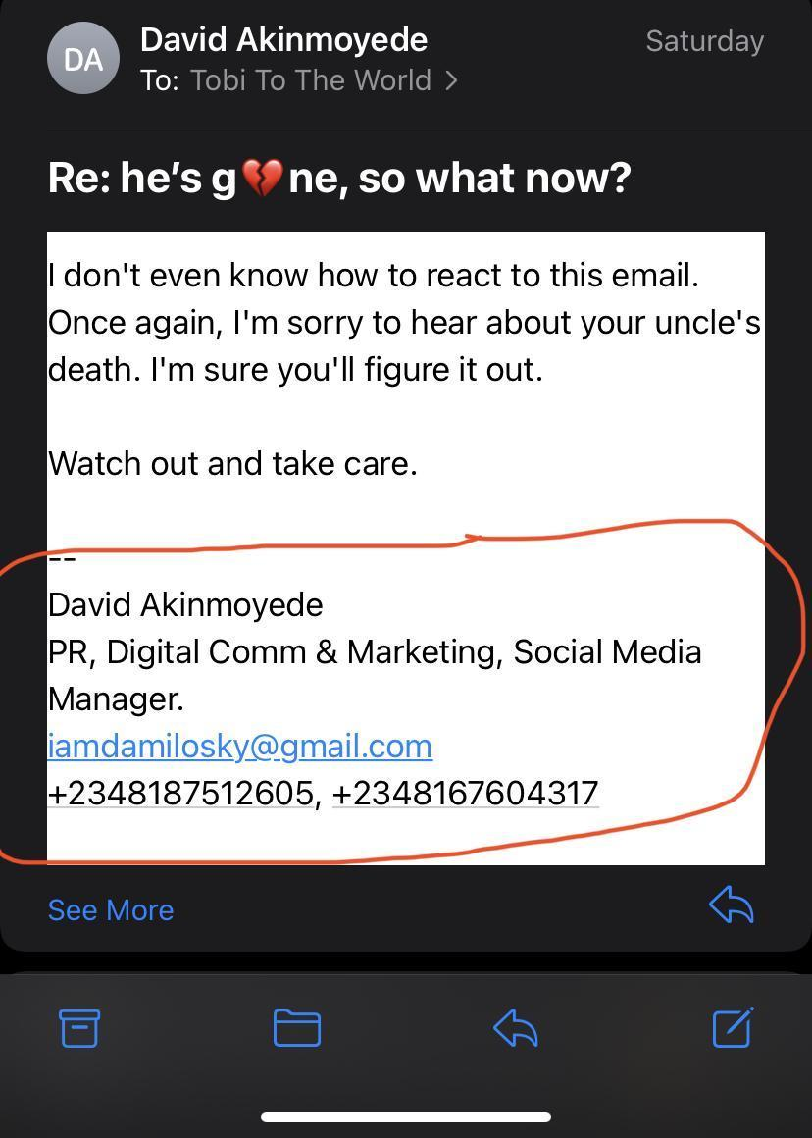

PS: we’d call you before you even send it out so you ask questions for any objections you have or any other reasons.

